Dairy-CropSyst
User Manual
Developed by: Tariq M. Khalil, Claudio O. Stöckle, Bryan R. Carlson, Roger L. Nelson
Contributors: Nicole Uslar-Valle, Craig S. Frear, Jingwei Ma
Biological Systems Engineering
College of Agricultural, Human, and Natural Resource Sciences
Washington State University
Pullman, WA 99164-6120

Contents
Disclaimer 2
Acknowledgement 3
Introduction 4
Model Description 4
Model Architecture and System Requirement 5
Installation 6
The installation folder and you 8
Meet your new Editor 8
Running your own scenarios 10
Weather and Soil Data 11
Building up virtual farm and linking soil and weather files 11
Getting Simulation Output 12
Appendix 1 14

Disclaimer
Neither the Biological Systems Engineering nor the Washington State University nor any of their employees assumes any legal liability, responsibility for the accuracy and usefulness of any information. Reference to any special commercial process does not necessarily constitute or imply endorsement or recommendation. The views and opinions of the authors do not necessarily state or reflect those of Washington State University and shall not be used for advertising or product endorsement.

Acknowledgement
This work was sponsored, in part, by USDA National Institute of Food and Agriculture (Contract Number 2012-6800219814), Center for Sustaining Agriculture and Natural Resources, Washington State University, and the United States Environmental Protection Agency through Cooperative Agreement No. RD-83556701 with the Water Environment Research Foundation (WERF) National Research Center for Resource Recovery and Nutrient Management.

Introduction
Dairy confined animal feeding operations (CAFOs) may have deleterious effects on the environment by concentrating nutrients and emitting high amounts of greenhouse gasses (GHG). To reduce these effects in the United States, CAFOs are required to implement plans to minimize the natural resource contamination and to report GHG and ammonia emissions that exceed EPA guidelines.
The IPCC protocol for GHG emission lack farm level resolution, similarly the use of constant emission factors has proven insufficient for quantifying the gaseous emission from livestock operations. Use of modelling tools may aid in planning and evaluating farm scale mitigation efforts. A model that accommodates the impact of existing and emerging manure treatments on emissions and nutrient fate would provide more comprehensive simulation for whole-farm nutrient cycle.

Model Description
Dairy-CropSyst is a decision support tool for researchers, extensionists, and CAFO managers. It could be used to evaluate the effects of different manure treatment options including anaerobic digestion, nutrient recovery, and solid separation on net GHG emission and manure nutrient fate from a whole-farm perspective from the barn to crop land application. The model integrates established models, performance parameters of different manure treatments, and a cropping systems model, CropSyst, to predict the soil nutrient budget and carbon footprint.
At various stages on a dairy facility manure nutrients undergo different chemical reactions driven by environmental factors. The mass balance of these nutrients in organic and inorganic form is modeled as they pass from one stage to another on a daily time step. An animal sub-model based on feed intake, milk production, and body weight simulates the CO₂ and CH₄ emission during respiration and enteric fermentation, manure production, and manure nutrient composition from a single lactating cow. Manure excreted by the animal is received on the barn floor and stays there for 6-12 hrs depending on the frequency of manure scrape/flush. The main process occurring during this time is the urea hydrolysis to total ammonium nitrogen (TAN) and subsequent NH₃ volatilization. A small fraction of C and N is also mineralized from manure in the barn. Dairy-CropSyst uses an empirical model to estimate CO₂ and CH₄, while N₂O emission from the barn floor is estimated using an emission factor. In the lagoon, manure stays for a prolonged time until field conditions allow manure application. During lagoon storage, the manure organic matter decomposes releasing CO₂ and CH₄. This process is simulated using a three-pool first order decay model corrected for temperature and dissolved oxygen concentration. During decomposition, the organic N in the lagoon is converted into inorganic form. This ammonification is estimated using the C:N ratio of manure and the N is added to the existing TAN pool. Major N losses from the lagoon are in the form of NH₃ volatilization, however some N is also mineralized during nitrification and denitrification. The manure is pumped out periodically to cropland for fertigation. A fertigation event is generated for a cropping systems model. But the manure gets treated for GHG reduction and nutrient recovery before it is stored in the lagoon. Dairy-CropSyst allows the user to select manure treatment options including AD, fiber separation, fine solids removal, and TAN recovery. Model default solids reduction and nutrient recovery factors for these treatments are based on published values and industry data. The field component of the simulation is handled by CropSyst, a well-known, tested model that is used to study the effect of cropping systems management on productivity and the environment. CropSyst simulates the soil water budget, soil-plant nitrogen budget, biomass production, crop yield, and carbon footprint.

Model Architecture and System Requirement
Dairy-CropSyst consists of three independent executables that communicate through a common database (Figure 2). The user interface (Client.exe) is a Windows Presentation Foundation application coded in C# using the Model-view-viewmodel design pattern. The user interface runs on the Microsoft .NET 4.5 framework. The dairy model and associated file input and output logic (scenario_run.exe) are contained in a Windows console application and were coded in C++. The field model, CropSyst (CropSyst_4.exe), is a Windows console application coded in C++. The database consists of a series of text-based and binary files located on the user’s hard drive.
Figure 1 illustrates the program architecture, the user enters information using client.exe which writes the data to the database as a Dairy-Cropsyst scenario file, and, if a farm field is to be simulated, writes to a CropSyst scenario file. Next, the user invokes client.exe to run the model at which point scenario_run.exe is executed by client.exe. Then, scenario_run.exe reads the scenario and weather data from the database and runs the necessary dairy models and writes emission and nutrient data. If a farm field simulation is specified, scenario_run.exe writes fertigation and management information to the database and executes CropSyst_4.exe. Once the dairy models and, optionally, the field model is completed, scenario_run.exe aggregates output information and creates a Microsoft Excel file with a summary of the output. Finally, client.exe prompts the user that the simulation has finished and displays the results.
The software requires operating systems with Windows 7 or higher and Microsoft .NET 4.5 Framework, the program requires about 500 MB of hard drive space.

Figure 1. Relationships among the major components of Dairy-CropSyst. The user interface writes scenario-specific information to the database and executes the diary models and simulation logic, which in turn executes the field model. Each of the three components can run in isolation if the database is configured properly.
Dairy-CropSyst current version is intended for research and teaching, the weather and soil packaged is for demonstration only and cover part of the Washington and Idaho. The current user interface hides lot of complexity and feature of the model, a Pro version will be package with CS Suit in another version.

Installation
Installation files can be found at http://modeling.bsyse.wsu.edu/Dairy-CropSyst/
Install Dairy-CropSyst by running “setup.exe” and by following the on-screen instructions. The program will be installed to the Dairy-CropSyst directory in your Program Files (x86) folder.

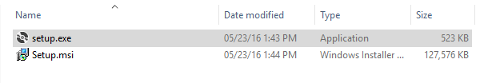
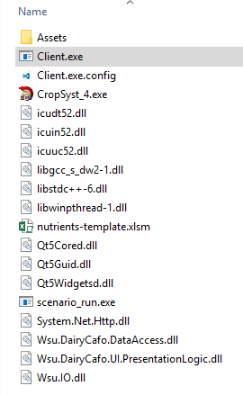

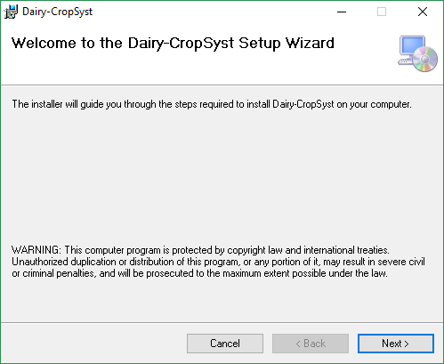

The installation folder and you
After the installation wizard has finished installing Dairy-CropSyst to your computer, browse to the installation directory (default is “C:\Program Files (x86)\DairyCropSyst”).
Do not make any changes to these files unless you know what you’re doing
Client.exe - The scenario editor; this is the tool that user likely be interacting with the most
CropSyst_4.exe – The CropSyst model. New versions will likely come out from time to time. You’ll need to overwrite this file (make a backup first!) and not the one in your CropSyst installation directory
nutrients-template.xlsm – This is used to create the excel output if output is enabled
scenario_run.exe – The dairy model. If you manually edit dairy scenario files, you’ll want to run this program from the command window or by using a bat file.
Assets – This is where template CropSyst scenarios reside as well as weather and soil files.

Meet your new Editor
- Double click on client.exe opens the user interface.
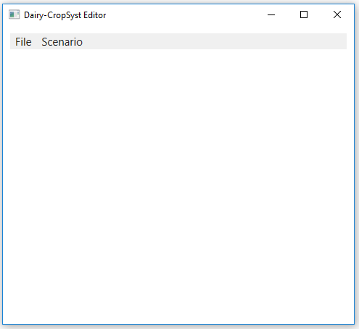
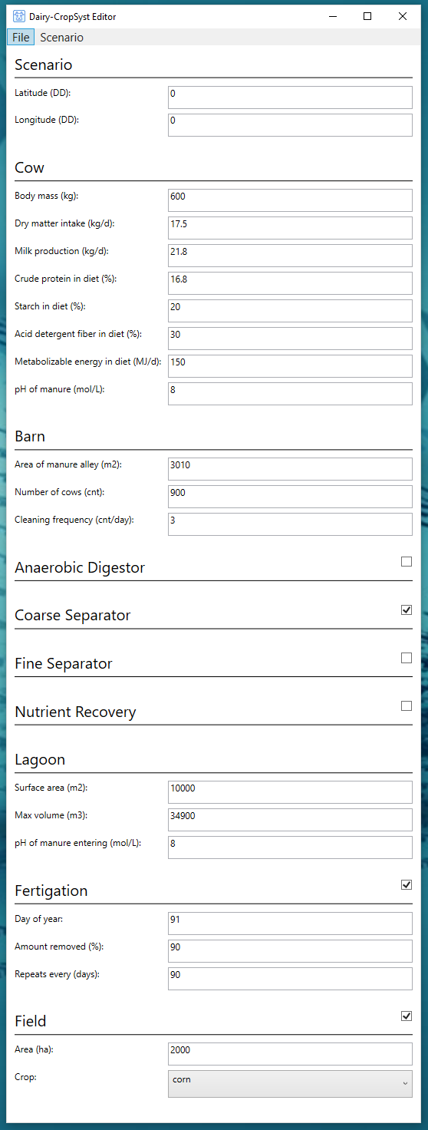
              - Click on File tab to opens a new or existing scenario.
              - Enter the coordinates of location, the user interface automatically load soil and weather info from the database
              - Build your virtual farm
              - To include crop field emission and nutrients fate check field and select a CropSyst scenario from drop down.
              - Save Scenario by clicking of file tab and save.
              - The saved scenario can be also edited in Notepad++
              - Run simulation by clicking on Scenario tab

Running your own scenarios
By default, Dairy-CropSyst only allows users to choose between two field types; alfalfa and corn. Both simulate monocropping … [template scenarios have not been created, will describe in details once we make some decisions].
If you wish to create a custom field simulation, then follow these steps:
1) Browse to a Dairy-CropSyst scenario directory, open the Fields directory. You should see a folder named either “corn” or “alfalfa”. [NOTE: Do not edit the name of the folder – if you do there is a chance the Editor will overwrite your custom scenario] Open the folder. This is the CropSyst scenario directory.
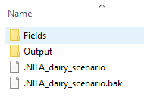 -> -> 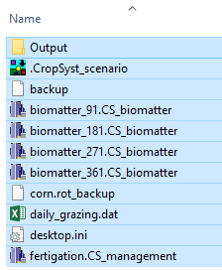
2) Select all the files and delete them
3) Copy the files from your custom CropSyst scenario into this directory
You are now ready to run the custom scenario from the Editor.
[NOTE: You may need to update the area of the field and enable the field in the Editor]
[NOTE: If you wish to use custom soil and weather then do not save the Dairy-CropSyst scenario via the Editor – this will overwrite soil and weather and set them to be the same geo-coordinates as the Dairy. You may run the scenario using the Editor but do not save it (alternatively, run the scenario using scenario_run.exe). Make sure to specify the area of the field in the CropSyst Scenario Editor or by adding “size=xxx” in the “[field]” section of the scenario file.]

Weather and Soil Data
Weather and soil parameter files are chosen by the Editor based on the latitude and longitude specified.
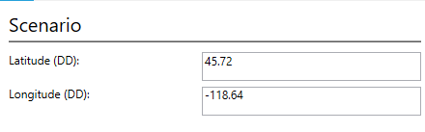
When the scenario is saved, the files in the Assets\Database\{Soil/Weather} directory of the installation directory are parsed and the nearest location to the specified geo-coordinates is chosen. [NOTE: A location will always be chosen, even if it’s thousands of miles away, so be careful.]

Building up virtual farm and linking soil and weather files
The existing data base cover only the location in States of Washington and parts of Southern Idaho where most of the state’s dairy operations exists. These tentative locations are highlighted in the map below with circle.
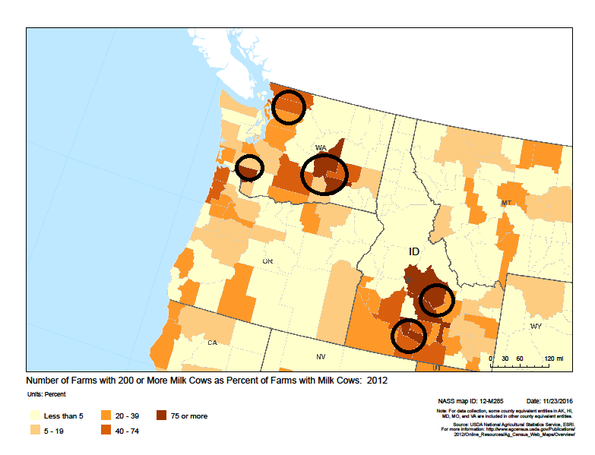
The supplied soil and weather databases can be supplemented to expand the spatial reach of the model or to use custom datasets. The files need to be in the following pattern following CropSyst UED format:
xx.xxxx{N/S}_xxx.xxxx{W/E}.UED and xx.xxxx{N/S}_xxx.xxxx{W/E}.CS_soil
where x is a number and {N/S} is either the character N or S and {W/E} is either the character W or E. For example, the following is for the weather file at the coordinates 48.9832, -122.4680:
48.9832N_122.4680W.UED
The weather and soil file should be saved at following locations, the program will extract them by entering the coordinates
C:\ProgramData\DairyCropSyst\Database\Weather
C:\ProgramData\DairyCropSyst\Database\Soil

Getting Simulation Output
When the scenario runs successfully the program display message.
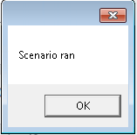
The model generates a common summary for both dairy farm and field crop.
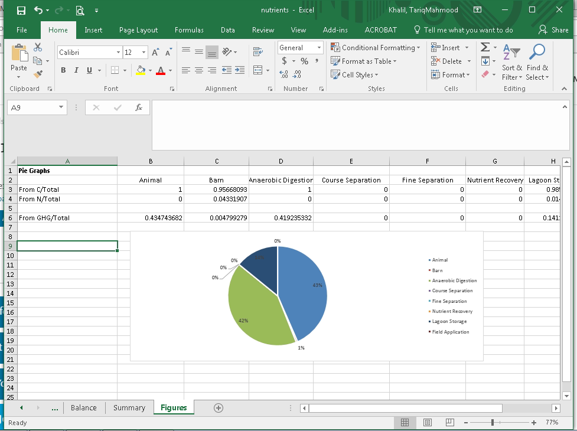

Daily value for dairy component are stored in text file
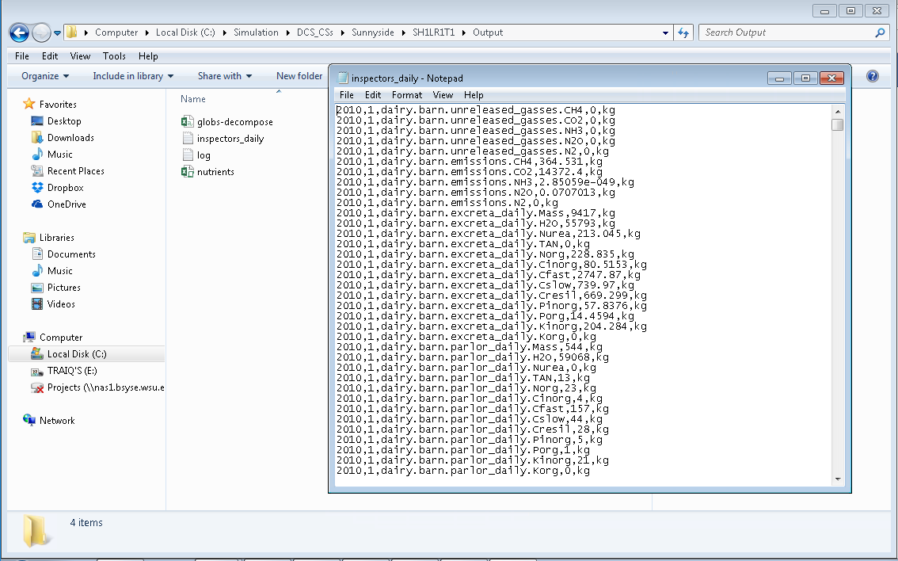
While the CropSyst output can be accessed from the field folder
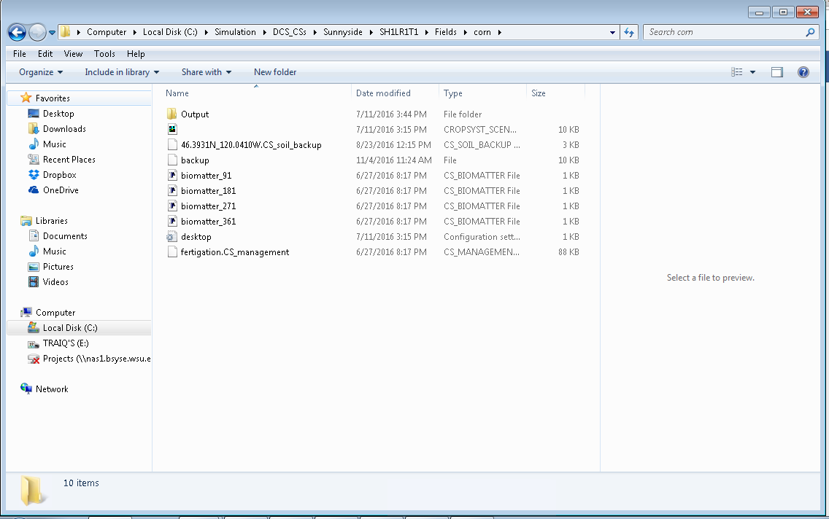

Appendix 1
Model processes characterizing dairy manure nutrients and emissions.
Description | Equation | Reference
Manure Production  Manure Excreted | $$M_{exc}=0.647×MP+43.212$$  M_{exc} = manure excreted by dairy cow (kg d⁻¹ cow⁻¹)  MP = Milk production (kg d⁻¹ cow⁻¹) | (ASABE, 2005)  (Nennich et al., 2005)
Urine Excreted | $$U_{exc}=0.017× BW+11.704$$  U_{exc} = Urine excreted (kg d⁻¹ cow⁻¹)  BW = Dairy cow body weight (kg)
Dry Matter Excreted | $${DM}_{exc}=0.35×{DM}_{I }+1.017$$  DM_{exc} = Dry matter in manure (kg d⁻¹ cow⁻¹)  DM_{I} = Dry matter intake (kg d⁻¹ cow⁻¹)
Manure Nutrients  Nitrogen Excreted | $$N_{exc}={(4.204×MP+283.3)}/{1000}$$  N_{exc} =Total nitrogen excreted in manure (kg d⁻¹ cow⁻¹) | (Bannink et al., 1999)  (de Boer et al., 2002)  (NRC, 2001)  (ASABE, 2005)  (Nennich et al., 2005)
Urine Nitrogen | $$N_{urine}={[75.18+0.719\left(-42.5+734×N_{diet}+1000×N_{milk}\right)]}/{1000}$$  N_{urine} = Nitrogen in urine (kg)  N_{diet} = Nitrogen in animal diet (kg)  $$N_{diet}=0.16(\frac{{CP}_{diet}}{100}×{DM}_{I})$$  CP_{diet} = Crud protein in animal diet (%)  N_{milk}= Nitrogen in milk (kg)  (Fresh milk contains about 3.2% of crude protein and 15.7% of it is considered to be nitrogen)
Carbon Excreted | $$C_{exc}=N_{exc}×C:N$$  C_{exc} = Carbon excreted in manure (kg d⁻¹ cow⁻¹)  C:N = Carbon nitrogen ratio in fresh manure
Phosphorus Excreted | $$P_{exc}={(0.773×MP+46.015)}/{1000}$$  P_{exc} = Phosphorous excreted in manure (kg d⁻¹ cow⁻¹)
Potassium Excreted | $$K_{exc}={(1.8×MP+31.154)}/{1000}$$  K_{exc} = Potassium excreted in manure (kg d⁻¹ cow⁻¹)
Dairy Barn Emission  Carbon Dioxide | $${CO}_{2 Barn}= N×{CO}_{2 resp}+ {A×CO}_{2 floor}$$  $${CO}_{2 resp}= -1.4+0.42×{DM}_{I}+0.0045×{BW}^{0.75}$$  $${CO}_{2 floor}= max⁡(0, 0.05075+0.00185×T_{air})$$  CO_{2 resp} = Carbon dioxide respired by dairy cow (kg d⁻¹ cow⁻¹)  CO_{2 floor} = Carbon dioxide emitted from manure on barn floor (kg d⁻¹ m⁻²)  N = Number of dairy cows  A = Area of barn manure alley (m²)  T = Temperature (°C) | (Kirchgessner et al., 1991)  (Rotz and Chianese, 2008)
Methane | $${CH}_{4 Barn}= N×{CH}_{4 resp}+ {A×CH}_{4 floor}$$  $${CH}_{4 resp}= 0.018×(E_{max}-E_{max}×e^{-c ME})$$  $$c= -0.0011×\frac{Starch_{f}}{ADF_{f}}+0.0045$$  $${CH}_{4 floor}= max⁡(0, 0.029+0.14×T_{air})$$  E_{max} = 45.98 (MJ CH₄ head⁻¹ d⁻¹)  ME = Metabolized energy intake (MJ head⁻¹ d⁻¹)  CH_{4 resp} = Dairy cow enteric fermentation methane emission(kg d⁻¹ cow⁻¹)  CH_{4 floor} = Methane emitted from manure on barn floor (kg d⁻¹ m⁻²)  Starch_{f} = animal feed starch fraction  ADF_{f} = Acid detergent fiber fraction in feed
Urea Hydrolysis | $$r_{urea= \frac{r_{max⁡_urea}× |Urea|}{K_{urea+|Urea|}} × V}$$  r_{urea} = Urea hydrolysis (kg d⁻¹)  r_{max_urea} = 0.162 (kg m⁻³ min⁻¹)  |Urea| = Urea N concentration (kg N m⁻³)  K_{urea} = 0.056 (kg N m⁻³)  V = volume of manure (m³) | (Monteny et al., 1998)
NH₃ Volatilization | $$Φ_{barn}=\frac{\left[k ×A_{barn}×f×TAN\right]}{H}$$  Φ = ammonia volatilization (kg N d⁻¹)  A = lagoon surface area  k = ammonia mass transfer coefficient (m d⁻¹)  f = fraction of ammonia nitrogen in TAN  TAN = Total ammonium N concentration (kg N m⁻³)  H = Henry constant
Lagoon Processes and Emission  Carbon Mineralization | $$C_{min}=f_{T}×f_{DO}(k_{l}×C_{l}+ k_{s}×C_{s}+ k_{r}×C_{r} )$$  C_{min} = Carbon Mineralized (kg d⁻¹)  f_{t} = temperature correction factor  f_{DO} = dissolved oxygen correction factor  k = decomposition rate constant (d⁻¹)  C= Carbon (kg)  Subscript “l” = labile pool  Subscript “s” = slow pool  Subscript “r” = recalcitrant pool  Where  $f_{t}=\max{[0, {({2.32}^{2 } × T^{2}- T^{4}}/{{32}^{4})}]}$ and  $f_{DO}=\max{[0, \frac{maxDOana-DO}{maxDOana+DO}]}$ + $\max{[0, \frac{DO-minDOan}{DO+minDOna}]}$  DO = Dissolved oxygen (mg l⁻¹)  maxDO_{ana} = Maximum dissolved oxygen at which anaerobic decomposition stops (i.e. 1 mg l⁻¹)  minDO_{ana} = Mimimum dissolved oxygen at which aerobic decomposition stops (i.e. 0.1 mg l⁻¹) | (Paul et al., 1999)  (Schomberg et al., 2002)  (Asaeda et al., 2000)
Nitrification | $$r_{Nitr}=r_{\max{Nitr }}×C_{T}×C_{pH}×\left(\frac{\left|{NH}_{4}\right|}{\left|{NH}_{4}\right|+ K_{NH4}}\right)×\left(\frac{DO}{K_{DO}+DO}\right)×V$$  r_{Nitr} = nitrification rate (kg N m⁻³)  |NH4| = ammonium concentration (kg N m⁻³)  K_{NH4} = half time ammonium saturation constant (1kg N m⁻³)  K_{DO} = half time DO saturation constant (2 mg l⁻¹)  C_{T} = Temperature correction factor  $$C_{T}= e^{0.098(T-15)}$$  C_{pH} = pH correction factor  $$C_{pH}= {1-0.833 \left(7.2-pH\right) If 6.0 ≤pH <7.2 \atop 1 If pH ≥7.2 }$$ | Kadlec & Knight (1996)
Denitrification | $$r_{Denit}=k_{Denit-20C}×Ө×\left|NO{}_{3}\right|×V$$  r_{Denit} = denitrification rate (kg N d⁻¹)  |NO₃| = nitrate concentration (kg N m⁻³)  V = volume of manure(m³)  Ө = temperature function  $$θ= {1.09}^{(T-20)}$$ | Kadlec & Knight (1996)
N₂O Emission  NH3 Emission | $$N_{2}O= r_{N2O_{Dnitr}}+r_{N2O_Nitr}$$  $$r_{N2O_Nitr}={\left|{NO}_{3}\right|}_{i}×(-0.0005×T+0.0126)$$  $$r_{N2O_Dnitr}=\frac{r_{Denitr}}{1+R_{\frac{N2}{N2O}}}$$  r_{N2O_Nitr}= N₂O emitted during Nitrification (kg N d⁻¹)  r_{N2O_Dnitr}= N₂O emitted during denitrification (kg N d⁻¹)  k_{Denit_20C} = denitrification rate at 20 °C ( 0.57 d⁻¹)  r_{Deni} = total denitrification (kg N d⁻¹)  R_{N2/N2O} = ratio of di-nitrogen to nitrous oxide  $$R_{\frac{N2}{N2O}}=23.5 ×[\frac{1.4}{{13}^{(\frac{17}{{13}^{2.2}})}}]$$  $$Φ_{lagoon}=\frac{\left[k ×A_{lagoon}×f×TAN\right]}{H}$$  Φ = ammonia volatilization (kgN d⁻¹)  A = lagoon surface area  k = ammonia mass transfer coefficient (m d⁻¹)  f = fraction of ammonia nitrogen in TAN  TAN = Total ammonium N concentration (kgN m⁻³)  H = Henry constant | (Maag & Vinther, 1996)  (Parton et al., 1996)
Volume Balance | $$V_{\left(lagoon\right)i}=V_{\left(lagoon\right)i-1}+ V_{\left(in\right)i}-V_{\left(out\right)i}- V_{loss}+ PPT$$  $$V_{\left(lagoon\right)i}=volume of lagoon on current day$$  $$V_{\left(lagoon\right)i-1}=volume of lagoon on previous day$$  $$V_{\left(in\right)i}=Volume recieved by lagoon$$  $$V_{\left(out\right)i}=volume pumped out on current day$$  $$V_{loss}=Evaporation and Seepage losses$$  $$V_{loss}=\left[\frac{0.622U_{r}C_{e}}{R_{d}T_{s}}\left(e_{s}-e_{a}\right)\right]+\left[\frac{K_{S}}{A} \left\{A_{s}\left(\frac{H}{2L}+1\right)+A_{b}\left(\frac{H}{L}+1\right)\right\}\right]$$  $$PPT=Precipitation$$  es = saturation vapor pressure at the temperature of the water surface (Pa)  ea = vapor pressure of the air (Pa)  Rd = gas constant (287.04 J kg⁻¹ K⁻¹)  Ts = temperature of the surface (K)  Ur = wind speed at 1 m (m s⁻¹)  0.622 = ratio of the molecular weights of water and dry air  Ce = bulk transfer coefficient (dimensionless, 2.8x 10⁻³)  A = area of the liquid surface (m²)  Ks = saturated hydraulic conductivity (m s⁻¹)  H = waste depth above the bottom of the lagoon (m)  As = areal area of the submerged side embankments (m²).  Ab = areal area of the flat bottom (m²). | (Ham, 2001)

